#spp different for Carbon? significant ( < 0.05) data

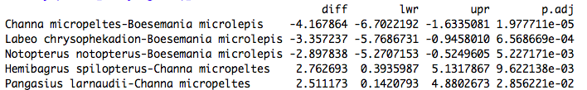

#does C vary by spp AND season? [additive] significant ( < 0.05) data

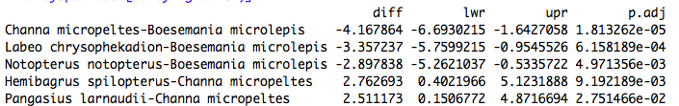

#does C vary by spp AND season? [interaction] significant ( < 0.05) data

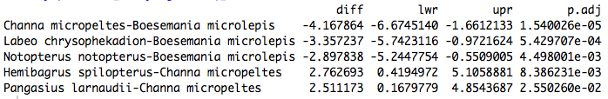

#spp different for Nitrogen? significant ( < 0.05) data

